1. Docker Version

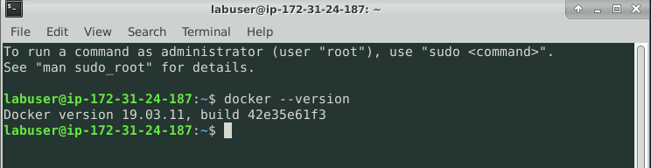

1. To Start the Docker on Linux :

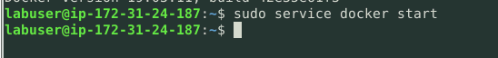

1. To Stop the Docker on Linux :

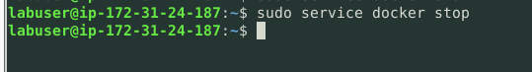

1. To check the running containers :

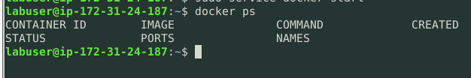

1. To check all the containers (running and terminated) :

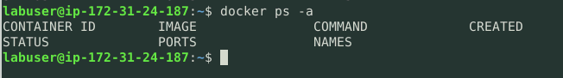

1. To check docker images :

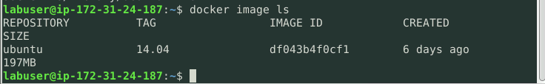

1. Pull an image

